**LAB TASKS**

**STRUCTURES**

**Task 01**

Write a C program can be used to read item details used in party and calculate all expenses, divide expenses in all friends equally. This program will read item name, price, quantity, number of friends and calculate amount and equally divide among friends.

**Task 02**

Create a structure named distance with two integer members feet and inches. Create a user define function named addDistance() that will take two structure objects as argument and print sum (addition) of them.

**Task 03**

Write a 'C' program to accept book details for 'n' books as book_no, book_title, author, publisher and cost using structures. Display these details as,  
  
1. Books of a specific author  
2. Books by a specific Publisher  
3. All Books costing Rs. 500 and above.  
4. All Books.

**Task 04**

Write a C program to accept details of 'n' employee(eno, ename, salary) and display the details of employee having highest salary. Use array of structure.

**Sample output**

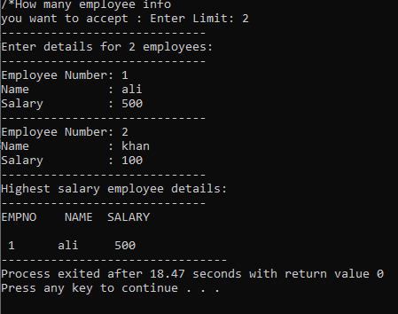

**Task 05**

Write a structure to store the name, account number and balance of customers (more than 10) and store their information

1 - Write a function to print the names of all the customers having balance less than $200.  
2 - Write a function to add $100 in the balance of all the customers having more than $1000 in their balance and then print the incremented value of their balance.

**Task 06**

A phone number, such as (212) 767-8900, can be thought of as having three parts: e.g., the area code (212), the exchange (767), and the number (8900). Write a program that uses a structure to store these three parts of a phone number separately. Call the structure phone.

Create two structure variables of type phone. Initialize one, and have the user input a number for the other one. Then display both numbers.

The interchange might look like this:

Enter area code: 415

Enter exchange: 555

Enter number: 1212

Then display like below:

My number is (212) 767-8900

Your number is (415) 555-1212

**NESTED STRUCTURES**

**Task 07**

Create a struct to store two data for a person: name and date of birth. The date of birth must be another struct consisting on day, month and year. Finally, create an array of persons, ask the user for the data of two persons and display them.

**Task 08**

Write a program that has two structures named school and student. The structure school contains two variables sch_Name, sch_id. Student structure contains four variable stu_id, stu_name, marks, Avg and also the structure address of school with that object such that school structure can be accessed from inside the student structure.

Create a function getData() to take record from user. How many records he wants to enter must also be asked.

Create a function display() to print the records of all students entered.